In search of a photograph
© Warren Carroll 2004
A lot of Americans, Canadians and British don’t realize how close we have really been in aviation. From Bell, McCurdy, Sufferage and Curtiss at the turn of the Century to the first war when the US Navy supplied bases in Nova Scotia and training of The Royal Canadian Air Service at The Massachusetts Institute of Technology in 1918.Because of convoys leaving Nova Scotia to England, the US Navy wanted to have aircraft guard the ships and the Canadians wanted to start an Air Service that would do the same.
There is a vast gap in the history of the RCNAS, records have disappeared, dress regulations are non existent and most historians think it was started in mid1918 and ended on November 11, 1918. However over the past years I have learned that it was actually disbanded in December 1919.
The reader should know at this point that the Service was originally commanded by a combination of British and Canadians under the jurisdiction of the Royal Air Force even though it was to be part of the Naval Branch. The other interesting decision was that the uniforms were based on the naval designs but the ranking was to be that of the Army which was parallel to the traditions of the RAF in 1918.
There is on record, a list of some eighty-one men who joined as Flight Cadets some of which went to England but only in1997 did we know that 60 went to MIT. That information along with notes on memos from August 1919 was found in US Naval Intelligence files, dated April 14, 1921 basically asking who was to pay the bill for the training expenses.
In the records it states that there were three classes, Number 32 with seven members, 33 with twenty-eight and 34 with thirty. Those who completed had all graduated by January 19, 1919.

One of the Cadets who joined was Earl J. Marsh and he started in MIT class 32, on October14, 1918 graduating in December 1918. We obtained some very interesting material from the Marsh family. He had a dog tag that was dated October 13, 1918 etched with his name and on the back is his fingerprint. This is typical of the style the US Navy provided at the time. Later on November 22, 1918 he received a certificate showing that he had obtained the rank of Ensign which is the lowest commission a US Naval Officer could get. Why we are not sure.
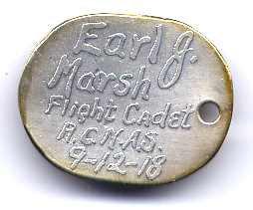©
In a letter dated December 2 to his mother he mentions that officers of the RAF and RCNAS came to MIT in a week before to tell the men that the time had come to pack up. However Marsh states that he was to go to Miami or Key West, Florida by boat from New York. ( I believe he might have been assigned to Pensacola for further aircraft training.) He also mentions that two unnamed classmates were to go to Akron Ohio for lighter than air training (by Goodyear pilots on free and kite balloons and powered airships.) Marsh had received a cap badge (unlike his Cadet badge) and wings at some point in time which seems to indicate he was now a pilot and possibly an officer of some type.
I have interviewed one other family of a Cadet who did not go to MIT but was shipped to England to train at a Balloon School at Roehampton. He was notified by letter on March 26, 1919 that his services were no longer needed by Feb.14, 1919. His discharge paper with the War Services badge shows “Flight Cadet.
They do have the Officer’s cap badge and a good collection of photographs. Although they all show cadets clearly there is none that show officers wearing any wings or the badges. On the back of one photo his mother had written “Ft Lt.” Apparently he had wings but they say they were lost at some point, well after he got back.
The details.
Photographs have been found from MIT that just show cadets, and the Rohampton ones, plus five cap badges have been located and five sets of the wings are now known.
Two named uniforms with naval buttons have been located and both came from US collectors. One was only a service dress jacket with no insignia and the other had a jacket, pants and named hat with the cap badge. This is interesting in that both were the same as the Cadet issue but one had revised buttons (1910 Chief Petty Officer’s). Both jackets had shoulder straps added in such a way that would indicate rank insignia was to be worn. This would suggest that they were most probably to be Second Lieutenants using the RAF ranking. Photos show there were no straps on their jackets when in training.
So the question is:
has anyone out there, come across a good photograph that would detail any RCNAS officers, their uniforms and badges?
Any information on this group, records, comments or leads would be most appreciated.
Warren Carroll carrol@pathcom.com

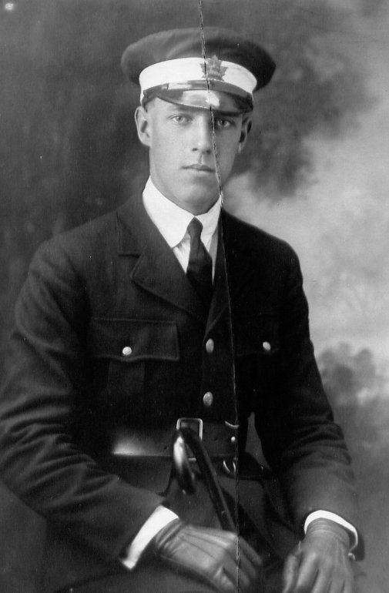
©
Marsh in the RCNAS uniform
and the cadet cap badge
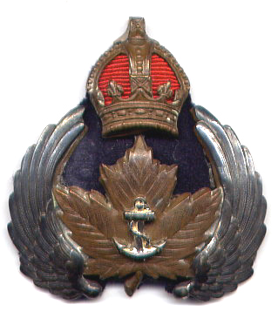

The Officer’s Cap badge
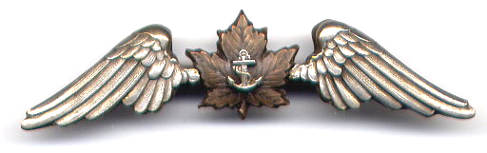
©
The wings.

